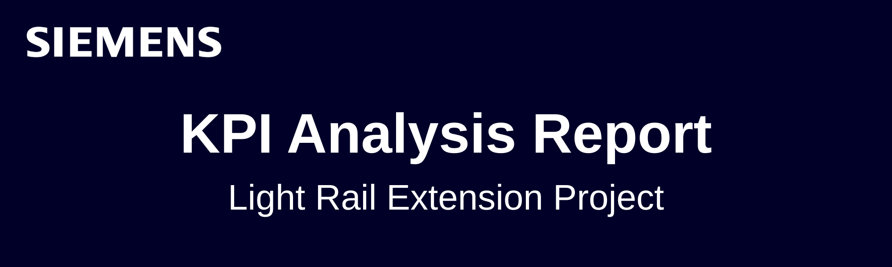
Project Overview
Project Name: Light Rail Extension Project
Phase: Construction
Reporting Period: April- May

KPI Performance Summary
Cost Performance Index (CPI)
Target: 1.0
Current: 0.92
Analysis: The CPI for the April–May reporting cycle stands at 0.92, below the target of 1.0, indicating cost overruns and inefficiencies in project delivery. The primary driver is material costs exceeding forecasts due to ongoing supply chain delays, especially affecting procurement of electrical systems. Close attention is required to mitigate further overruns and improve cost control in upcoming cycles.
Schedule Performance Index (SPI)
Target: 1.0
Current: 1.05
Analysis: The SPI is 1.05, which means the project is slightly ahead of schedule for the reporting period. Track installation teams have been working overtime to recover from previous weather-related delays. The schedule recovery is positive, but this approach should be balanced to avoid additional labor costs or potential fatigue that could impact quality.

Risk Closure Rate
Target: 80%
Current: 65%
Analysis: Risk closure performance is below the target, with only 65% of identified risks resolved. The main issue pertains to unresolved electrical system integration concerns, which have not yet been fully addressed during this cycle and could impact both schedule and cost if left unattended.
Forecast at Completion (FAC)
Target: $100M
Forecast: $105M
Analysis: The FAC predicts the project will run $5M over budget. Most of the overruns are anticipated in electrical systems materials and integration, exacerbated by supply chain uncertainty and open risk items.

Risks and Opportunities
Identified Risks:
- Electrical system integration issues remain open, risking further delays and added costs.
- Vendor performance for electrical components under review due to quality and delivery concerns.
- Client sensitivity to delays is heightened because of the upcoming stadium opening.

Opportunities:
- Track installation teams demonstrated flexibility and effective recovery measures by accelerating work in response to delays.
- Early milestone achievements could trigger incentive bonuses if teams maintain current pace.

Recommendations
- Strengthen Cost Controls:
Enhance procurement monitoring and negotiate with suppliers to minimize further cost escalation due to supply chain delays.
- Accelerate Risk Closure:
Allocate dedicated resources to resolve open risk items, particularly in electrical systems, ensuring integration issues are prioritized.
- Balance Schedule Acceleration:
Identify areas where further schedule recovery can occur without excessive overtime costs or risks to quality, and consider additional incentives for achieving early milestones.

Conclusion
The project continues to face cost pressures and unresolved risks but demonstrates effective schedule recovery for this reporting period. Ongoing monitoring and proactive management are essential to avoid further overruns and ensure successful delivery against stakeholder expectations.

